ASSEMBLE INSTRUCTIONS FOR SMALL ROCKING HORSE:

Tools Needed:
Electric Drill
Hammer
Phillips screwdriver bit
Staple gun (arrow GT21 Style)
Hot glue gun
Scissors

Materials Enclosed:
1 body with angle blocks mounted
1 handle bar
1 seat
4 legs with left and right marked on the bottom
2 rockers
5 cross pieces
Glue
25 2” screws (extra screws included)
10 3" screws (extra screws included)
20 3/8” screw hole buttons (extra buttons included)
8 ½” screw hole buttons (extra buttons included)
2 ½” flat buttons for the seat
3 Hair Jigs (16” for tail, 6” for mane, 3” for under ears)
Skein yarn
Ears

Stain or Paint?
The first step is to decide whether you are going to stain it or paint it. Staining or painting should be done before you put the rocking horse together.
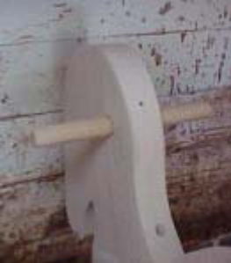
After the stain or paint has dried you are ready to assemble your rocking horse.

Angle Blocks – already attached to the body.

Handle Bar
Insert the handle bar in the hole to lines as marked on the bar, approximately 3 ¼” should show on each side. Secure with a 2 inch screw.

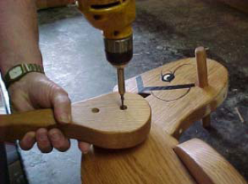
Seat: Attach seat to body using 3” screws. Make sure seat is properly installed, front is marked on bottom of seat. Put glue on the sides & bottom of the ½” flat button. Place the buttons in the seat holes, take a piece of scrap wood on top of the buttons and tap lightly until the buttons are flat with the seat surface. Let glue dry and sand as needed.

Legs
Next, you need to attach the legs.
You will notice that each leg has a letter code on the bottom.
RF = Right Front RR = Right Rear
LF = Left Front LR = Left Rear
Make sure all legs are in the appropriate place.
Don't put a rear leg in the front, or a front leg in the rear.
Take a 3 inch screw and run the screw in the top hole of the leg and into the top pre-drilled hole of the angle block. Leave the screw loose, allowing the leg to rotate as needed.
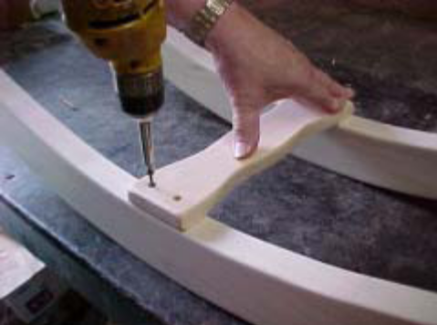
Put all 4 legs on with just the top screw. (Note: Insert screw thru leg until tip appears to align with top hole of leg angle block.)
Rockers and crosspieces
After you assemble the legs, it's time to put the cross pieces on the 2 rockers.
Attach a crosspiece to both rockers with 2" screws (2 screws on each side). Initially install only one screw on each side until all crosspieces are attached, then repeat the process with the second screw in each crosspiece. Recommend starting in the center and repeat the procedure with the other pieces.
Match the numbers on the crosspieces to the corresponding numbers on the rockers.
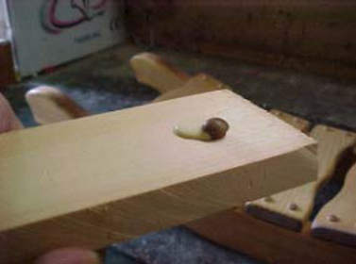
After you have screwed the cross pieces to the rockers you can put 3/8" buttons on the crosspieces.
To do this you put some glue on a scrap piece of wood or paper. Slide
the buttons thru the glue so that the sides of the buttons are covered. Slide the button thru the glue and not just dipping it in the glue. Insure that glue is on the sides and bottom of the button, place the button in the screw hole, tap lightly with a hammer to seat in place then wipe any excess glue from the side and top after button is installed.

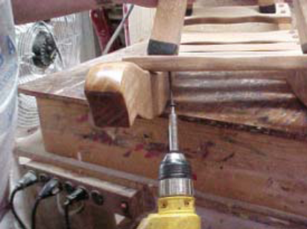
Body to Rockers
Put the body on the crosspieces. Match the holes in the front and back crosspieces to the appropriate pre-drilled leg.
Be careful not to bump the side of the rocker with the drill bit.
Make sure you angle your bit with the leg.
Do not tighten the screws in any leg until all four legs are in place, then go back and complete each leg
Insert a 3" screw into each front leg.
Turn the horse around and do the same with rear legs, putting a 2" screw in each rear leg.

Finish attaching legs to the body
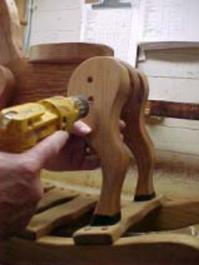
Put 2nd 3" screw in the bottom hole of each leg. Holes have been pre-drilled. Repeat this process for all 4 legs.
Put ½" inch button in holes (be sure to get glue on the sides of the buttons).
Now that the 4 legs are in place with second screw in each leg go back and secure the top screw in each leg.

Congratulations, the assembly process for your rocking horse is complete. It’s time to give it ears, a mane and tail.

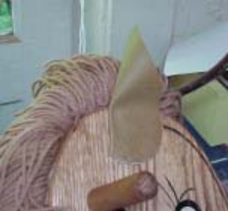
Ears: Identify the location you want the ears to be and draw the back and bottom of the ear on the horse’s head. Place some hot glue on the bottom inch of the rough side of the ear then fold the heart shaped ear in half. Make sure the curved part of the ear is facing forward. Place a couple staples in the ear (as shown on the picture) to hold it in place.
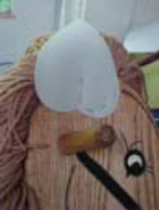
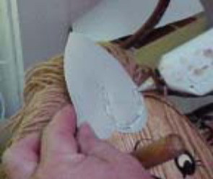
Using the 3” yarn template wrap yarn around the template 10 to 12 times and cut the bundle. Staple the bundles across the bottom of the ear, it should take approximately 6 bundles for each ear. Double check when installing the second ear to insure that it is even with the first ear you installed.

Mane
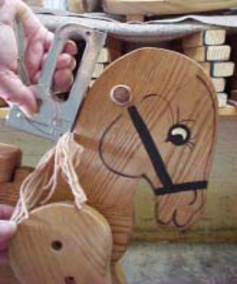
Your horse is fully assembled and the ears are in place, let’s give it some hair. First find the end of the yarn in the center of the skein end. Pull from that end.
Wrap the yarn around the 6” hair jig 12 times. Cut off all 12 strands.
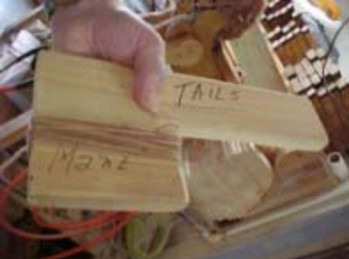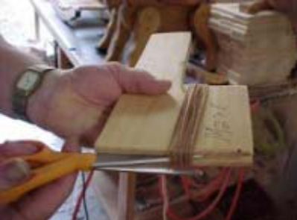
Staple on the head beginning about 2” from the bottom of the neck and continue to a point approximately even with the handle on the front of the face (your choice of where to start and stop the mane).

You will need 3 rows of yarn on the head, one on each side and 1 in the center.
Repeat this process till the mane is done to your satisfaction. Recommend gluing the yarn to the horse with a hot glue gun, this can be done as you staple each bundle or go back and glue after completed. Shorter hair (12”) on back of head, working to longer strings on the top & forehead (16”).

Tail: For the tail you use the longest hair jig.

Wrap the jig 10 to 12 times and cut the yarn.
Attach one bundle to the back of the horse about 2 inches from the back of the seat. Attach bundles in a circle from top to bottom about 1 ½” diameter with a couple bundles in the center of the circle (10 to 12 bundles will do the job).
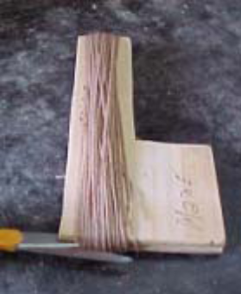
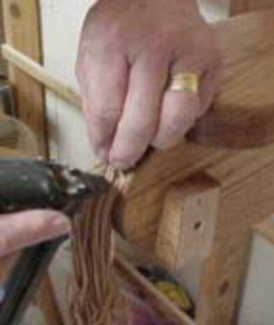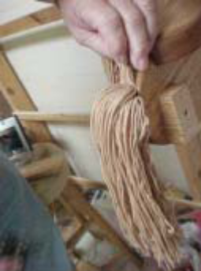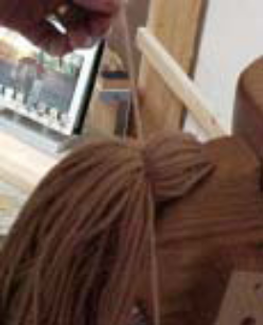

Save 1 strand of yarn to tie around the tail when all bundles have been stapled and glued. With your fingers comb the tangles of the tail. Have someone hold the tail straight up in the air while you tie a single strand of yarn about 1” from the base of the tail.

Last Step: Get out your scissors and give your horse a hair cut. Long hair, short hair, long tail, etc. Make him/her your horse to fit your personal desires and decorations.

CONGRATULATIONS, YOU HAVE COMPLETED YOUR ASSEMBLY PROCESS.
PUT ANY DESIRED FINISHING TOUCHES ON YOUR HORSE AND
ENJOY FOR GENERATIONS TO COME.

